

Mr. Smith Johnson Warehouse digital warehouse organization

Table of Contents

Executive Summary 2

System initiation 3

Ishikawa (Fishbone) diagram 3

Problem Analysis 4

Scope and Goal 5

Systems Analysis 6

Procedure 6

Point of sale systems 7

**Hardware- Computer Desktop** 8

**Software** 10

People (Staff) 12

Solution 13

Cost and benefit Analysis 13

Systems Design 14

Data Flow Diagram 14

Entity Relational Diagram 16

Relational Diagram 17

Database SQL 17

Populated table 19

Customers table 19

Product table 21

Account table 24

Supplier table 26

Warehouse table 26

Retrieved tables 27

Conclusion 40

Citation: 42

# **Executive Summary**

Mr. Smith Johnson has been the owner of a medium size distributorship that sells shoes, footwears and other accessories for more that 5 years. The warehouse consists of shoes from Adidas, Converse, Roxy, Nike, Clarks, Puma, New balance, Madden Girl, and many more brands, and various kinds of shoe accessories like hand bags, drawstring bags, duffel bags, scarves and wraps, backpacks, assorted socks, polish, laces, even shoe racks. Mr. Smith Johnson’s consumer based is composed of local small shoe stores and thrift stores, individual shoe shiners and shoe repairers in his district. Over the last few years, his sales have increased leading his business booming.

When Mr. Smith Johnson started his company ten years ago, he only had 50 customers and an average sale of 25 a week. During that time, it was easier and cheaper to keep his record manually using paper. His system until now consists of keeping customers details on index cards in a file box. This system might have been effective back then but now, Mr. Smith Johnson business has significantly increased with almost 500 customers, an inventory over 5000 items and an average 50 orders per day. This increase in number has drastically change his business structure.

Despite all this increase in numbers, Mr. Smith Johnson still uses his old manual book keeping. This has led his distributorship to having some business issues, such as: out-of-date customer records, an increase in the number of orders resulting manual processing difficulties, a lack of inventory management, and missed market opportunities. Also. The concept of manually processing orders and checking customer balances is also slowing business growth. These issues are causing sales and income losses,while Mr. Johnson wants to increase his profit by making distribution more efficient and long-lasting. With the technology and digital innovation existing today, he can have a computerize system to help his handle his business better and keep up with his increasing demand.

# **System initiation**

## **Ishikawa (Fishbone) diagram**

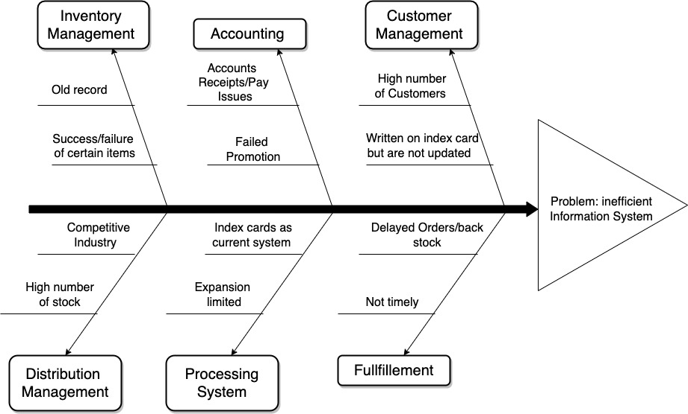

## **Problem Analysis**

The Ishikawa Diagram, also known as fishbone diagram is a problem solving and root cause analysis tool. In the contest of Mr. Smith Johnson’s distributorship, it defines the root cause of his numerous problems as the use of index card for customer recited leading to the inefficient record keeping and others.

The first problem with Mr. Smith Johnson business is customer record management. With a growing customer base nearly 500, the existing system of keeping customers data on index cards in a file box on counter is becoming obsolete and inefficient. Because the records are out of date, and difficult to target customer for specific promotion.

Second, he has a problem with inventory management. The distributorship offers over 5000 items, some of which have been sitting in the warehouse for months. Mr. Johnson is not able to track the trying to sell trends of these items, making inventory management difficult and avoiding overstock or excess stock difficult.

Third, he has a problem of order processing. As number of orders increased (from 25 per week to 50 per day), Mr. Johnson's manual order processing procedures could not keep up with the business's growth. As a result, purchase fulfillment is delayed, and customers are dissatisfied.

Forth, he has trouble with promoting his business . Due to out-of-date customer information, some promotions fall flat, resulting in sales and income losses. Also, account receivable is another is another problem the manual process for checking customer account balance and following up on past-due accounts is so overburdened that it's difficult to follow up.

Finally, the last problem is an increase in competition. As competition grows, Mr. Johnson’s distributorship must become more efficient and up-to-date in order to stay competitive.

## **Scope and Goal**

Mr. Smith Johnson’s business problem expends between the information systems and the outdated technology he uses. The goal  is to automate and computerize his system by converting his current index card system into an automated digital platform that will ensure this efficiency of his business. To be able to accomplish his objectives, Mr. Smith Johnson will need the help of a consulting company. After research I found that BDO Digital LLC. will be the best fit to help him. BDO Digital LLC. is a global consulting company that offers technology and advisory services to organizations of all sizes. They provide a variety of services such as software development, digital transformation, cybersecurity and cloud services etc. In the case of Mr. Johnson Smith, BDO Digital LLC. will help him in four main categories: keep a digital customer record management, have an inventory management system, keep his orders processing and keep online presence. This will solve his root problems, increase his numbers and make his business more efficient. BDO Digital LLC. will also equip Mr. Johnson smith with some telecommunication, computer hardware and technology to improve his information system.

In order to get in track of his business new, Mr. Smith Johnson’s main goal is to convert into a digital platform. In the process of implementing a new management and information system, he need to make sur to contain all his company’s documentation and record organized in one place. The system should be capable to track inventory and notify them in case of any change or updated data. This will allow him to have control and a board view over on his inventory and products, about what products are not selling much, which ones are popular and which products he has to restock on. Also, on another point, the system will be automatically updated every time there is an entry, this will keep track of customer account with their payment and show the outstanding balance.

Generally speaking, BDO Digital LLC. can assist Mr. Smith Johnson in improving his business by introducing him to automation and technology. These changes will enable him to keep track of in and outs of his business and make his business use pleasant for his users.

# **Systems Analysis**

Prior to start analysis, the individuals should consider how they intend the scheme to manage customer information they want to have. They should consider how it would improve their costumers experience and benefit the business overall. Also, system analysis project are generally imitated for three reasons: to find the problem, find the opportunities and chose the directive to implement. All through the course of Mr. Smith Johnson project, BDO Digital LLC will be in charge of the system analysis, they will the software and the hardware technology necessaire. They will also present the cost benefit analysis between the old paper system and the digital system they will implement.

## Procedure

In order to keep data organized in place and constantly up to date, They should be a database implementation with access to the internet (a cloud base storage). These changes will involve the implementation of new system hardware system including mainly a desktop computer and a point-of-sale system. This is where Mr. Smith Johnson’s business processing system will drastically be transformed from physical paper to digital system and it will ensure smooth operations.

### Point of sale systems

Point of sale (POS) system is the software and hardware that facilitate sales, accept payment and check customer record. This allows the company to manage all the transitions, have a detailed list of their customers, track their inventory and sales. After searching, we found that would be the best platform to host the Point of sale of Mr. Smith Johnson company.



Figure 3.1

Lightspeed is a point-of-sale system that provides software and hardware options to retail stores, restaurants and others. They propose one unified solution for online and in person retail which consisted of sell online and off, simplify back office and manage inventory and supplier. In the case of Mr. Smith Johnson, their system will be used in inventory management by tracking inventory levels in real time and receiving notifications when some of his products are running low. This will assist him in avoiding backorders and stockouts as well as determining which product are selling slowly or quickly. This POS system can help Mr. Johnson with sale reporting. It will track his sales, product category, product location and allow him to make more informed decision regarding his business. Lightspeed POS will keep track of the costumer’s information and their purchase history. This will assist him in the identification of his best customer to provide them with targeted discounts or promotions. This feature could also be used to develop personalized marketing campaign to appeal his customers. Lightspeed POD supports multi-channel sales, which includes in-store, online, and mobile. This presents an opportunity for Mr. Johnson to reach more customers and increase his sale if he decides to sell his product through multiple channels. Overall Lightspeed POS could help him improve his customer experience , modernize his streamline operation and increase his sales. One the other hand, they are also potential downsides in the implementation of Lightspeed Point of sale system. These downsides include the budget necessary to implement the smoot work of the system. Furthermore, if Mr. Johnson id unfamiliar with software and technology, he might find the system customization and setup difficult and time consuming.

### **Hardware- Computer Desktop**

Several factors must be considered when determining the appropriate hardware for Mr. Johnson’s Business. This includes the size of the business, the type of users (employees), the type of software that will be used and the specific need of the business. The computer desktop that we propose are known for their reliability and high performances.

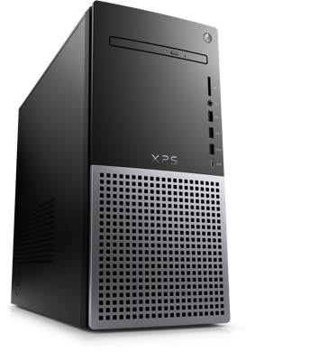

Figure 3.2

The Dell XPS Desktop 12th Gen Intel® Core™ i7-12700 (25 MB cache, 12 cores, 20 threads, 2.10 GHz to 4.90 GHz Turbo) is a good recommendation for Mr. Smith Johnson’s business. The 12th gen Intel Core processor delivers high performance with low power consumption. It allows for faster information processing, multitasking, and smoother operations, which can help Mr. Johnson's company run more quickly and efficiently. It has a large storage capacity of 1 TB SSD. Mr. Johnson's business information, software platforms, and files will have plenty of storage space. It can help to make sure that the system works properly and that Mr. Johnson has quick and easy access to the necessary data and files. This system will require system update at least once or twice a year. It is affordable and the price ranges between $1,556 6and $2,100.



Figure 3.3

The Apple iMac with Retina 5K display will be a good. Mr. Johnson can quickly see all the specifics of his business information, including inventory and customer records, on its 5K retina display. The Intel Core i7 processor, with a clock speed of 3.8GHz, can handle multiple tasks while maintaining smooth and quick achievement even during peak hours. The 8GB memory allows for the easy management of various applications and software all at the same time. Mr. Johnson can store and access a big quantity of data, which include customer data, sales figures, and inventory, thanks to the 512GB SSD storage. The iMac's sleek design can also add a professional look to the business, particularly if Mr. Johnson has a customer-facing area. Furthermore, Mr. Johnson's iMac comes with a pre-installed operating system and software that can be useful for his business requirements, such as iWork for generating and editing documents, spreadsheet applications. The price ranges between $1,800 and $2,300.

Overall, the iMac can be a dependable and efficient piece of hardware for Mr. Johnson's business, offering enhanced display, quickness, storage, and layout to support his everyday activities.

### **Software**

Systems software serves as the basis for infrastructure software, which manages hardware, networks, and software. The following software options can be useful for the specific issues that Mr. Johnson's company is experiencing:

* **Customer Relationship Management (CRM) software system**: Putting in place a CRM system would assist organize customer data, including contact information, order history, and preference information. Mr. Johnson would be able to better manage his expanding customer base and provide better customer service as a result. Popular CRM programs include HubSpot, Zoho CRM, and Salesforce.
* **Inventory Management software**: Inventory management software is necessary for Mr. Johnson since he has a lot of products in his warehouse and wants to make sure that none of them are hanging around in excess. He can keep track of inventory levels, predict demand, and simplify the purchasing process by putting in place an inventory management system. TradeGecko, Skubana, and Zoho Inventory are a few well-liked solutions for inventory management software.



Figure 3.4

* **Accounting software**: Manually maintaining financial records can be time-consuming and error-prone. Mr. Johnson can automate bookkeeping processes like invoicing, costs, and payroll by implementing accounting software. Popular accounting software alternatives that can be tailored to Mr. Johnson's company's needs include QuickBooks, Xero, and FreshBooks.



Figure 3.5

* **Point of Sale software**: Mr. Johnson can manage transactions more effectively with the use of a POS system by processing payments, monitoring sales, and controlling inventory levels. Popular POS software solutions with capabilities like inventory management, customer tracking, and sales analytics include Lightspeed POS, Square, and Shopify POS.



Figure 3.6

* **Marketing Automation software**: Mr. Johnson might use marketing automation tools to develop and manage email campaigns, social media marketing, and targeted promotions to boost sales and customer engagement. Popular marketing automation software choices like HubSpot Marketing, Marketo, and Mailchimp can assist automate repetitive operations and improve marketing strategy.



Figure 3.6

Using these software options will help Mr. Johnson's company become more productive overall, enhance customer service, and boost sales. It is crucial to select software that fits the unique requirements of the company and to guarantee that the team has received the necessary training to operate it efficiently.

## **People (Staff)**

The following skill sets would be required for the staff to effectively handle the computer solutions required in Mr. Johnson's business:

* **IT Support Specialist**: This employee would be in charge of offering technical support for the company's hardware and software systems. They must be familiar with computer equipment, software platforms, connectivity, and security procedures.
* **Database Administrator**: This employee would be in charge of maintaining and updating the company's customer database. They should have prior experience with database administration, data processing, and data protection.
* **Software Developer**: This employee would be in charge of personalizing and establishing software solutions to suit the specific needs of the company. Programming languages, software tools, and agile project methodologies should be familiar to them.
* **E-commerce Manager**: This employee would be in charge of overseeing the online marketplace and promoting the company's services and products. They must be familiar with e-commerce systems, digital marketing, and web analytics.
* **Sales Representatives:** These employees would be in charge of interacting with customers, serving customers, and resolving customer problems. They should have strong communication, sales, and customer service skills.

To effectively handle the computer solutions required in Mr. Johnson's business, the staff would need a combination of technical, analytical, and interpersonal skills.

# Solution

The administration of customers, sales, and inventories provide numerous difficulties for Mr. Johnson's company. A complete solution that incorporates hardware, software, and staff training is advised to address these issues.

First off, updating the computer systems' hardware to a new Dell XPS Desktop or an Apple iMac Pro would increase their speed and effectiveness. Mr. Johnson will be able to process client orders and inventory adjustments in real-time thanks to this. A modern point of sale system, such as Lightspeed Commerce POS, will also give the company an integrated platform for monitoring sales, inventory, and customer information. Mr. Johnson will be able to make decisions about product offerings and customer interaction as a result.

In order for the personnel to make the most of the new gear and software in order to accomplish business objectives, it will also be important to teach them on it. To deliver outstanding customer service, precisely maintain inventories, and evaluate sales data for future decision-making, a professional workforce will be necessary.

Last but not least, the cost-benefit analysis shows that the long-term return on investment for the new hardware, software, and employee training will be positive. Mr. Johnson's company will be able to run more smoothly and make more money because to improved inventory management, quicker sales processing, and improved customer involvement.

## **Cost and benefit Analysis**

Using a Lightspeed Commerce Point of Sale system linked with BDO Digital's consulting services could assist Mr. Johnson solve his problem by streamlining his business operations and increasing efficiency. This would entail investing in hardware, such as the Apple iMac Pro or the Dell XPS Desktop, as well as hiring and educating knowledgeable personnel to manage the computer systems. To ascertain whether or not this option is financially feasible, a cost-benefit analysis should be done.



# **Systems Design**

## Data Flow Diagram

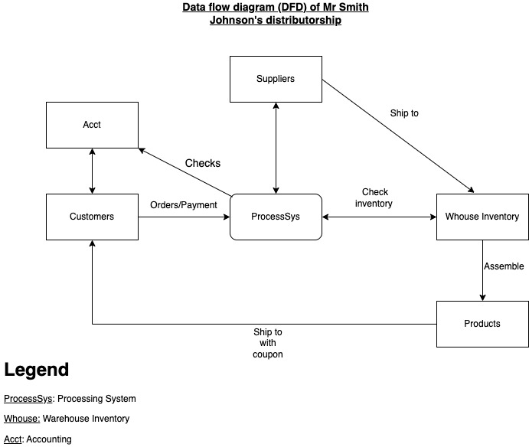

## Entity Relational Diagram

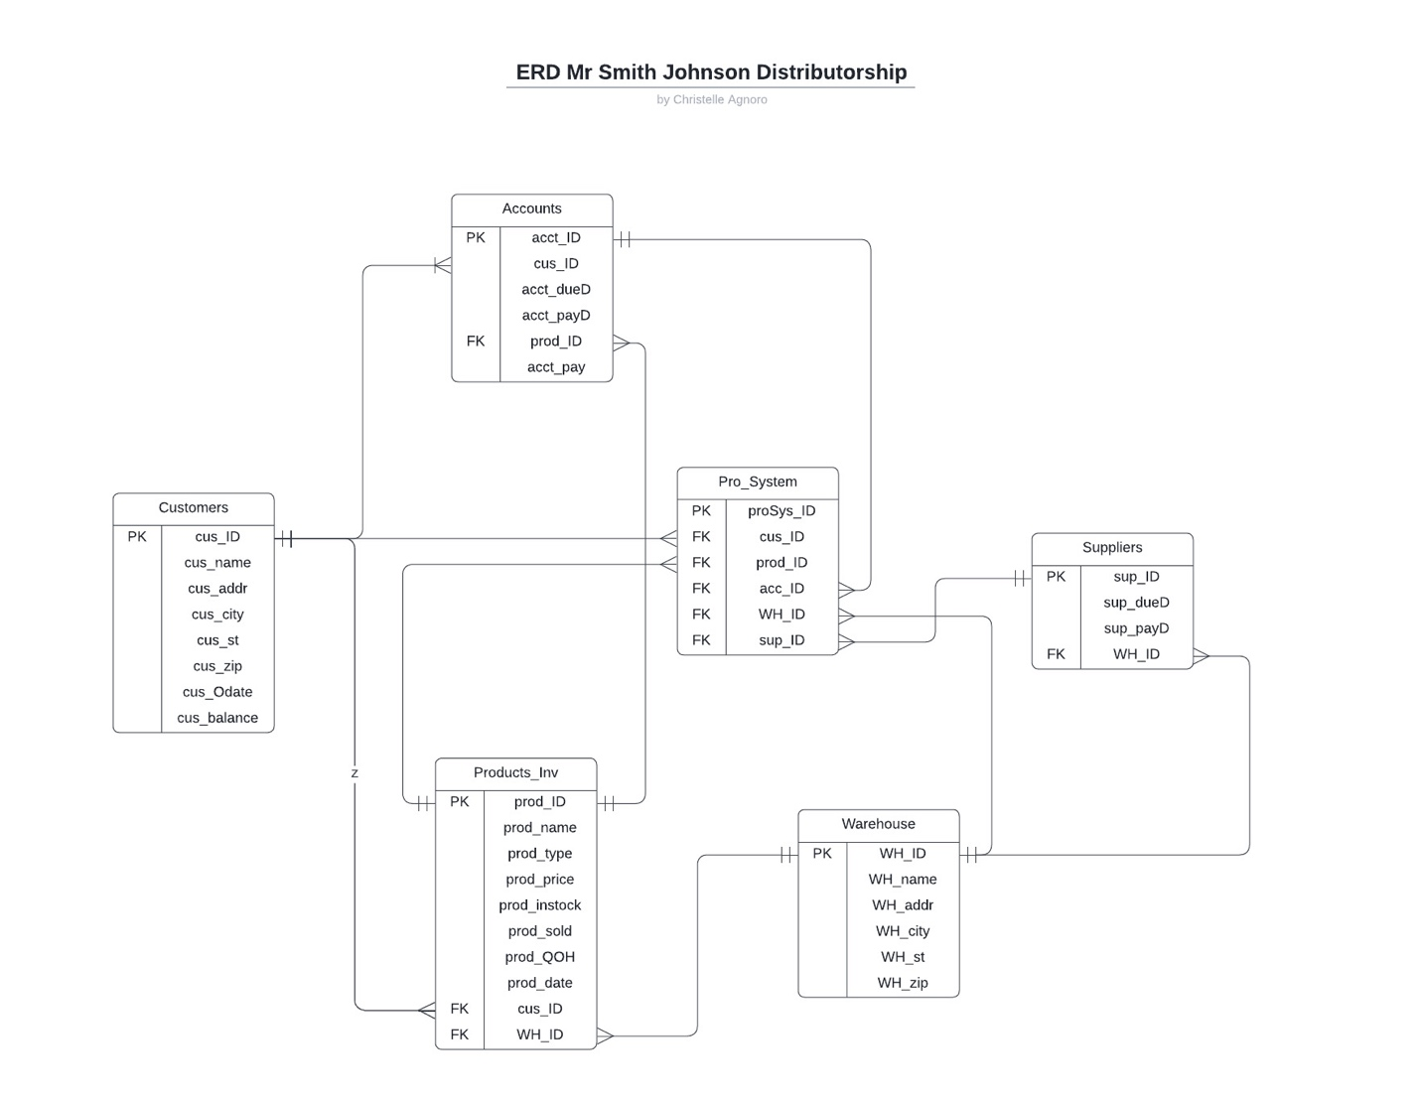

## Relational Diagram

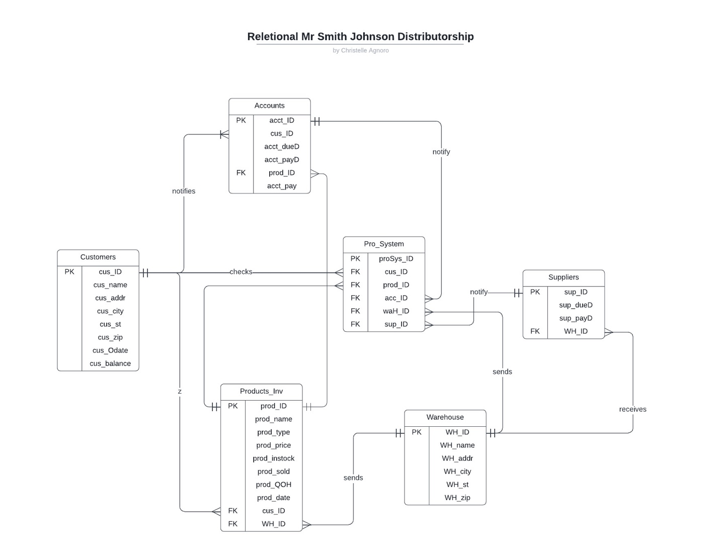

## Database SQL

CREATE TABLE Customers

(

cus_ID INT AUTO_INCREMENT NOT NULL,

cus_name VARCHAR(50) NOT NULL,

cus_Addr VARCHAR(50) NOT NULL,

cus_city VARCHAR(50) NOT NULL,

cus_st VARCHAR(50) NOT NULL,

cus_zip VARCHAR(50) NOT NULL,

cus_Odate DATE NOT NULL,

cus_Balance decimal(15,2) NOT NULL,

PRIMARY KEY (cus_ID)

);

CREATE TABLE Warehouse

(

WH_ID INT NOT NULL,

WH_name VARCHAR(50) NOT NULL,

WH_Addr VARCHAR(50) NOT NULL,

WH_city VARCHAR(50) NOT NULL,

WH_st VARCHAR(50) NOT NULL,

WH_zip VARCHAR(50) NOT NULL,

PRIMARY KEY (WH_ID)

);

CREATE TABLE Accounts

(

acc_ID INT AUTO_INCREMENT NOT NULL,

acc_dueD DATE NOT NULL,

acc_payD DATE NOT NULL,

cus_ID INT NOT NULL,

sup_ID INT NOT NULL,

prod_type VARCHAR NOT NULL,

PRIMARY KEY (acc_ID),

FOREIGN KEY (cus_ID) REFERENCES Customers(cus_ID),

FOREIGN KEY (sup_ID) REFERENCES Suppliers(sup_ID),

FOREIGN KEY (prod_type) REFERENCES Products(prod_type)

);

CREATE TABLE Products

(

prod_ID INT AUTO_INCREMENT NOT NULL,

prod_name VARCHAR(50) NOT NULL,

prod_type VARCHAR(50) NOT NULL,

prod_price decimal(15,2) NOT NULL,

prod_instock INT NOT NULL,

prod_sold INT NOT NULL,

prod_QOH VARCHAR(50) NOT NULL,

prod_date DATE NOT NULL,

WH_ID INT,

PRIMARY KEY (prod_ID),

FOREIGN KEY (WH_ID) REFERENCES Warehouse(WH_ID)

);

CREATE TABLE Suppliers

(sup_ID INT NOT NULL,

sup_dueD DATE NOT NULL,

sup_payD DATE NOT NULL,

WH_ID INT NOT NULL,

PRIMARY KEY (sup_ID),

FOREIGN KEY (WH_ID) REFERENCES Warehouse(WH_ID);

CREATE TABLE Pro_Sys

(proS_ID INT NOT NULL,

prod_ID INT NOT NULL,

prod_name VARCHAR(50) NOT NULL,

cus_ID INT NOT NULL,

WH_ID INT NOT NULL,

sup_ID INT NOT NULL,

acc_ID INT NOT NULL,

PRIMARY KEY (proS_ID),

FOREIGN KEY (prod_ID) REFERENCES Products(prod_ID),

FOREIGN KEY (cus_ID) REFERENCES Customers(cus_ID),

FOREIGN KEY (WH_ID) REFERENCES Warehouse(WH_ID),

FOREIGN KEY (acc_ID) REFERENCES Accounts(acc_ID),

FOREIGN KEY (sup_ID) REFERENCES Suppliers(sup_ID)

);

## **Populated table**

### Customers table

|  |  |  |  |  |  |  |  |  |
| --- | --- | --- | --- | --- | --- | --- | --- | --- |
| **cus_ID** | **cus_name** | **cus_Addr** | **cus_city** | **cus_st** | **cus_zip** | **cus_Odate** | **cus_Balance** | **acct_ID** |
| **1** | Linda Brown | 246 Elm St | San francisco | CA | 12345 | 2023-01-03 | 0.00 | 1 |
| **2** | Mark Johnson | 753 Oak St | Austin | TX | 67890 | 2021-03-01 | 3000.00 | 2 |
| **3** | Samantha Lee | 842 Maple Ave | Chicago | IL | 54321 | 2022-05-01 | 0.00 | 3 |
| **4** | David Green | 963 Elm St | Circus | NY | 54321 | 2022-06-01 | 0.00 | 4 |
| **5** | Brian Davis | 625 Cedar St | San Antonio | CA | 12345 | 2022-10-01 | 100.00 | 5 |
| **6** | Anna Brown | 246 Elm St | Long beach | CA | 12345 | 2022-12-01 | 120.00 | 6 |
| **7** | Michael Davis | 625 Cedar St | Chicago | IL | 54321 | 2022-11-01 | 0.00 | 7 |
| **8** | Jessica Black | 714 Pine St | San Diego | CA | 12345 | 2022-09-01 | 900.00 | 8 |
| **9** | Andrew Clark | 427 Oak St | Houston | TX | 67890 | 2022-07-01 | 700.00 | 9 |
| **10** | Michael Davis | 625 Cedar St | Chicago | IL | 54321 | 2013-07-09 | 0.00 | 10 |
| **11** | Eric Lee | 318 Maple Ave | Houston | TX | 67890 | 2015-07-06 | 0.00 | 11 |
| **12** | Daniel Green | 963 Elm St | Somewhere | TX | 67890 | 2016-04-08 | 0.00 | 12 |
| **13** | Emily Wilson | 536 Birch St | Here | NY | 54321 | 2018-06-04 | 250.00 | 13 |
| **14** | Jane Doe | 84 Milles St | Baltimore | MD | 23433 | 2022-10-01 | 0.00 | 14 |
| **15** | John Dawson | 235 Main st | Baltimore | MD | 20394 | 2022-03-10 | 0.00 | 15 |
| **16** | Bob Jones | 644 Louisville st | Harlem | NY | 30454 | 2021-04-09 | 0.00 | 16 |
| **17** | Raven Smith | 435 Carlton St | Charlotte | NC | 24959 | 2022-03-04 | 0.00 | 17 |
| **18** | Amy Castro | 243 Rock rd | Rockville | MD | 20901 | 2021-05-08 | 0.00 | 18 |
| **19** | Jammy Ruiz | 646 Tartr st | Bethesda | MD | 20916 | 2020-09-04 | 100.00 | 19 |
| **20** | Oliver Lee | 543 Rusk rd | Washington | DC | 20020 | 2021-10-01 | 200.00 | 20 |
| **21** | Evelyn Ozborne | 84 Nelson Bow st | Phoenix | AZ | 67939 | 2022-01-02 | 150.00 | 21 |
| **22** | John Smith | 484 Mulla rd | San Diego | CA | 39474 | 2023-01-01 | 0.00 | 22 |
| **23** | Bob Johnson | 4958 Pomme st | Houston | TX | 68473 | 2022-09-12 | 0.00 | 23 |
| **24** | John Smith | 123 Main St | Anytown | NY | 12345 | 2022-01-01 | 0.00 | 24 |
| **25** | Mary Johnson | 456 Elm St | Smallville | CA | 67890 | 2022-01-02 | 0.00 | 25 |
| **26** | Tom Williams | 789 Oak St | Big City | TX | 23456 | 2022-01-03 | 0.00 | 26 |
| **27** | Samantha Davis | 321 Pine St | Suburbia | FL | 34567 | 2022-01-04 | 0.00 | 27 |
| **28** | Bob Anderson | 654 Maple St | Hometown | IL | 45678 | 2022-01-05 | 0.00 | 28 |
| **29** | Jenny Lee | 987 Cedar St | Metropolis | GA | 56789 | 2022-01-06 | 100.00 | 29 |
| **30** | Alex Wright | 147 Sunset Blvd | Beachside | CA | 67891 | 2022-01-07 | 0.00 | 30 |
| **31** | Emily Wilson | 258 Sunrise Ave | Seaside | FL | 78901 | 2022-01-08 | 50.00 | 31 |
| **32** | Mike Brown | 369 Park Ave | Cityville | TX | 89012 | 2022-01-09 | 0.00 | 32 |
| **33** | Katie Jones | 741 Forest Rd | Ruraltown | IL | 90123 | 2022-01-10 | 0.00 | 33 |
| **34** | Chris Taylor | 852 Meadow Ln | Countryville | GA | 1234 | 2022-01-11 | 0.00 | 34 |
| **35** | Jessica Green | 963 Mountain Rd | Mountainview | CA | 23456 | 2022-01-12 | 0.00 | 35 |
| **36** | David Rodriguez | 159 River St | Riverdale | FL | 34567 | 2022-01-13 | 0.00 | 36 |
| **37** | Karen Martinez | 357 Lake Dr | Laketown | TX | 45678 | 2022-01-14 | 0.00 | 37 |
| **38** | Andrew Kim | 468 Brookside Rd | Brookside | IL | 56789 | 2022-01-15 | 0.00 | 38 |
| **39** | Linda Chen | 579 Orchard Ave | Orchardville | GA | 67890 | 2022-01-16 | 0.00 | 39 |
| **40** | Scott Lee | 680 Pine St | Pineville | CA | 78901 | 2022-01-17 | 0.00 | 40 |
| **41** | Rachel Kim | 791 Maple Ave | Mapleton | FL | 89012 | 2022-01-18 | 0.00 | 41 |
| **42** | Daniel Lee | 902 Cedar Rd | Cedarville | TX | 90123 | 2022-01-19 | 0.00 | 42 |
| **43** | John Smith | 123 Main St | Anytown | NY | 12345 | 2022-01-01 | 0.00 | 43 |
| **44** | Mary Johnson | 456 Elm St | Smallville | CA | 67890 | 2022-01-02 | 0.00 | 44 |
| **45** | Tom Williams | 789 Oak St | Big City | TX | 23456 | 2022-01-03 | 0.00 | 45 |
| **46** | Samantha Davis | 321 Pine St | Suburbia | FL | 34567 | 2022-01-04 | 0.00 | 46 |
| **47** | Bob Anderson | 654 Maple St | Hometown | IL | 45678 | 2022-01-05 | 0.00 | 47 |
| **48** | Jenny Lee | 987 Cedar St | Metropolis | GA | 56789 | 2022-01-06 | 100.00 | 48 |
| **49** | Alex Wright | 147 Sunset Blvd | Beachside | CA | 67891 | 2022-01-07 | 0.00 | 49 |
| **50** | Emily Wilson | 258 Sunrise Ave | Seaside | FL | 78901 | 2022-01-08 | 50.00 | 50 |
| **51** | Mike Brown | 369 Park Ave | Cityville | TX | 89012 | 2022-01-09 | 0.00 | 51 |
| **52** | Katie Jones | 741 Forest Rd | Ruraltown | IL | 90123 | 2022-01-10 | 0.00 | 52 |
| **53** | Chris Taylor | 852 Meadow Ln | Countryville | GA | 1234 | 2022-01-11 | 0.00 | 53 |
| **54** | Jessica Green | 963 Mountain Rd | Mountainview | CA | 23456 | 2022-01-12 | 0.00 | 54 |
| **55** | David Rodriguez | 159 River St | Riverdale | FL | 34567 | 2022-01-13 | 0.00 | 55 |
| **56** | Karen Martinez | 357 Lake Dr | Laketown | TX | 45678 | 2022-01-14 | 0.00 | 56 |
| **57** | Andrew Kim | 468 Brookside Rd | Brookside | IL | 56789 | 2022-01-15 | 0.00 | 57 |
| **58** | Linda Chen | 579 Orchard Ave | Orchardville | GA | 67890 | 2022-01-16 | 0.00 | 58 |
| **59** | Scott Lee | 680 Pine St | Pineville | CA | 78901 | 2022-01-17 | 0.00 | 59 |
| **60** | Rachel Kim | 791 Maple Ave | Mapleton | FL | 89012 | 2022-01-18 | 0.00 | 60 |
| **61** | Daniel Lee | 902 Cedar Rd | Cedarville | TX | 90123 | 2022-01-19 | 0.00 | 61 |

### Product table

|  |  |  |  |  |  |  |  |
| --- | --- | --- | --- | --- | --- | --- | --- |
| **prod_ID** | **prod_name** | **prod_type** | **prod_price** | **prod_instock** | **prod_sold** | **prod_QOH** | **prod_date** |
| **1** | Adidas | Shoes | 120.00 | 200 | 150 | 50 | 2023-01-03 |
| **2** | Converse | Shoes | 160.00 | 200 | 198 | 2 | 2022-10-01 |
| **3** | Roxy | Shoes | 34.99 | 200 | 198 | 2 | 2022-12-01 |
| **4** | Nike | Shoes | 125.00 | 200 | 196 | 4 | 2022-11-01 |
| **5** | Clarks | Shoes | 124.99 | 200 | 199 | 1 | 2022-10-01 |
| **6** | Puma | Shoes | 75.00 | 200 | 178 | 22 | 2022-12-01 |
| **7** | New Balance | Shoes | 84.99 | 200 | 198 | 2 | 2022-11-01 |
| **8** | Maidden Girl | Shoes | 99.95 | 200 | 196 | 4 | 2022-11-03 |
| **9** | Adidas Samba | Causal | 70.00 | 200 | 198 | 2 | 2022-12-01 |
| **10** | Converse Chuck | Casual | 55.00 | 200 | 115 | 85 | 2013-07-09 |
| **11** | Roxy Bayshore | Casual | 49.00 | 200 | 159 | 41 | 2015-07-06 |
| **12** | Nike Air Max | Athletic | 120.00 | 200 | 196 | 4 | 2022-12-08 |
| **13** | Clarks Desert | Boots | 130.00 | 200 | 10 | 190 | 2023-01-01 |
| **14** | Puma Smash | Casual | 55.00 | 200 | 120 | 80 | 2022-10-01 |
| **15** | New Balance 990 | Athletic | 175.00 | 200 | 170 | 30 | 2022-03-10 |
| **16** | Madden Girl Sable | Pumps & Heels | 45.00 | 200 | 199 | 1 | 2021-12-09 |
| **17** | Sandals Flat | Sandals | 30.00 | 200 | 150 | 50 | 2022-03-04 |
| **18** | Boots Heeled | Boots | 90.00 | 200 | 145 | 55 | 2021-05-08 |
| **19** | Wide Width Loafers | Loafers & Slip-ons | 60.00 | 200 | 195 | 5 | 2022-12-04 |
| **20** | Causal Slip-ons | Loafers & Slip-ons | 40.00 | 200 | 90 | 110 | 2021-10-01 |
| **21** | Wedges Ankle Strap | Wegdes | 65.00 | 200 | 195 | 5 | 2022-11-02 |
| **22** | Flats Ballet | Flats | 35.00 | 200 | 125 | 75 | 2023-01-01 |
| **23** | Adidas Ultraboost | Athletic | 180.00 | 200 | 196 | 4 | 2022-12-12 |
| **24** | Leather Handbag | Handbag | 50.00 | 200 | 30 | 170 | 2022-11-01 |
| **25** | Canvas Tote Bag | Handbag | 30.00 | 200 | 40 | 160 | 2022-11-02 |
| **26** | Drawstring Backpack | Backpack | 25.00 | 200 | 195 | 5 | 2022-11-03 |
| **27** | Duffel Bag | Duffel Bag | 50.00 | 200 | 180 | 20 | 2022-01-04 |
| **28** | Silk Scarf | Scarf | 20.00 | 200 | 45 | 5 | 2023-01-01 |
| **29** | Wool Shawl | Scarf | 36.00 | 200 | 40 | 160 | 2022-12-13 |
| **30** | Ankle socks (6 pks) | Ankle socks (6 pks) | 12.00 | 200 | 100 | 10 | 2020-07-01 |
| **31** | Knee-High Socks (3pks) | Socks | 16.00 | 200 | 95 | 5 | 2017-01-08 |
| **32** | Boot Socks (2pk) | Socks | 15.00 | 200 | 5 | 195 | 2022-11-09 |
| **33** | Shoe Polish (black) | Shoe Polish | 5.00 | 200 | 196 | 4 | 2022-10-01 |
| **34** | Shoe Polish (brown) | Shoe Shoe Polish | 5.00 | 200 | 40 | 40 | 2020-11-02 |
| **35** | Leather Cleaner | Shoe Care | 8.00 | 200 | 20 | 2 | 2022-12-04 |
| **36** | Shoe Deodorizer | Shoe care | 6.00 | 200 | 195 | 5 | 2022-11-05 |
| **37** | Shoe Deodorizer | Shoe care | 7.00 | 200 | 20 | 180 | 2022-10-07 |
| **38** | Shoe Rack (2-tier) | Shoe Storage | 25.00 | 200 | 30 | 170 | 2023-01-01 |
| **39** | Shoe Rack (3-tier) | Shoe Storage | 35.00 | 200 | 30 | 5 | 2020-05-09 |
| **40** | Shoe Bag (single) | Shoe Storage | 2.50 | 200 | 1 | 199 | 2022-11-04 |
| **41** | Shoe Laces (round) | Shoe Laces | 3.00 | 200 | 80 | 20 | 2018-12-09 |
| **42** | Shoe Laces (flat) | Shoe Laces | 3.00 | 200 | 196 | 4 | 2022-12-04 |
| **43** | Shoe Insoles (leather) | Shoe Insoles | 10.00 | 200 | 44 | 156 | 2023-01-01 |
| **44** | Shoe Insoles (foam) | Shoe Insoles | 5.00 | 200 | 10 | 190 | 2022-10-03 |
| **45** | Boot Jack | Shoe Accessories | 15.00 | 200 | 59 | 21 | 2022-11-04 |
| **46** | Shoe Horn | Shoe Accessories | 7.50 | 200 | 198 | 2 | 2022-11-02 |
| **47** | Shoe Trees (cedar) | Shoe Care | 15.00 | 200 | 20 | 152 | 2022-11-01 |
| **48** | Loafers Tassel | Loafers | 70.00 | 200 | 197 | 3 | 2022-11-09 |
| **49** | Nike Air Force 1 | Athletic | 90.00 | 200 | 45 | 4 | 2022-10-04 |
| **50** | Roxy Bayshore II | Casual | 50.00 | 200 | 2 | 198 | 2013-01-01 |

### Account table

|  |  |  |  |  |  |
| --- | --- | --- | --- | --- | --- |
| **acc_ID** | **acc_dueD** | **acc_payD** | **cus_ID** | **sup_ID** | **prod_type** |
| **1** | 2022-01-15 | 2022-01-31 | 1 | 1 | Shoes |
| **2** | 2022-02-15 | 2022-02-28 | 2 | 2 | Shoes |
| **3** | 2022-03-15 | 2022-03-31 | 3 | 3 | Shoes |
| **4** | 2022-04-15 | 2022-04-30 | 4 | 4 | Shoes |
| **5** | 2022-05-15 | 2022-05-31 | 5 | 5 | Shoes |
| **6** | 2022-06-15 | 2022-06-30 | 1 | 2 | Shoes |
| **7** | 2022-07-15 | 2022-07-31 | 2 | 3 | Shoes |
| **8** | 2022-08-15 | 2022-08-31 | 3 | 4 | Causal |
| **9** | 2022-09-15 | 2022-09-30 | 4 | 5 | Causal |
| **10** | 2022-10-15 | 2022-10-31 | 5 | 1 | Causal |
| **11** | 2022-11-15 | 2022-11-30 | 1 | 3 | Athletic |
| **12** | 2022-12-15 | 2022-12-31 | 2 | 4 | Boots |
| **13** | 2023-01-15 | 2023-01-31 | 3 | 5 | Casual |
| **14** | 2023-02-15 | 2023-02-28 | 4 | 1 | Athletic |
| **15** | 2023-03-15 | 2023-03-31 | 5 | 2 | Pumps & Heels |
| **16** | 2023-04-15 | 2023-04-30 | 1 | 4 | Sandals |
| **17** | 2023-05-15 | 2023-05-31 | 2 | 5 | Food |
| **18** | 2023-06-15 | 2023-06-30 | 3 | 1 | Boots |
| **19** | 2023-07-15 | 2023-07-31 | 4 | 2 | Loafers & Slip-ons |
| **20** | 2023-08-15 | 2023-08-31 | 5 | 3 | Loafers & Slip-ons |
| **21** | 2022-03-01 | 2022-03-15 | 21 | 21 | Wegdes |
| **22** | 2022-04-01 | 2022-04-15 | 22 | 22 | Flats |
| **23** | 2022-05-01 | 2022-05-15 | 23 | 23 | Athletic |
| **24** | 2022-06-01 | 2022-06-15 | 24 | 24 | Handbag |
| **25** | 2022-07-01 | 2022-07-15 | 25 | 25 | Handbag |
| **26** | 2022-08-01 | 2022-08-15 | 26 | 26 | Backpack |
| **27** | 2022-09-01 | 2022-09-15 | 27 | 27 | Duffel Bag |
| **28** | 2022-10-01 | 2022-10-15 | 28 | 28 | Scarf |
| **29** | 2022-11-01 | 2022-11-15 | 29 | 29 | Scarf |
| **30** | 2022-12-01 | 2022-12-15 | 30 | 30 | Books |
| **31** | 2023-01-01 | 2023-01-15 | 31 | 31 | Ankle socks (6 pks) |
| **32** | 2023-02-01 | 2023-02-15 | 32 | 32 | Socks |
| **33** | 2023-03-01 | 2023-03-15 | 33 | 33 | Socks |
| **34** | 2023-04-01 | 2023-04-15 | 34 | 34 | Shoe Polish |
| **35** | 2023-05-01 | 2023-05-15 | 35 | 35 | Shoe Shoe Polish |
| **36** | 2023-06-01 | 2023-06-15 | 36 | 36 | Shoe Care |
| **37** | 2023-07-01 | 2023-07-15 | 37 | 37 | Shoe Care |
| **38** | 2023-08-01 | 2023-08-15 | 38 | 38 | Shoe Care |
| **39** | 2023-09-01 | 2023-09-15 | 39 | 39 | Shoe Storage |
| **40** | 2023-10-01 | 2023-10-15 | 40 | 40 | Shoe Storage |
| **41** | 2023-03-01 | 2023-03-15 | 4 | 3 | Shoe Storage |
| **42** | 2023-04-05 | 2023-04-20 | 1 | 2 | Shoe Laces |
| **43** | 2023-05-03 | 2023-05-15 | 5 | 4 | Shoe Laces |
| **44** | 2023-06-02 | 2023-06-17 | 2 | 1 | Shoe Insoles |
| **45** | 2023-07-01 | 2023-07-15 | 3 | 5 | Shoe Insoles |
| **46** | 2023-08-03 | 2023-08-18 | 4 | 2 | Shoe Accessories |
| **47** | 2023-09-02 | 2023-09-16 | 1 | 3 | Shoe Accessories |
| **48** | 2023-10-05 | 2023-10-20 | 5 | 1 | Shoe Care |
| **49** | 2023-11-03 | 2023-11-15 | 2 | 4 | Loafers |
| **50** | 2023-12-01 | 2023-12-15 | 3 | 2 | Athletic |

### Supplier table

|  |  |  |  |
| --- | --- | --- | --- |
| **sup_ID** | **sup_dueD** | **sup_payD** | **WH_ID** |
| **1** | 2022-01-15 | 2022-02-15 | 1 |
| **2** | 2022-02-20 | 2022-03-20 | 2 |
| **3** | 2022-03-15 | 2022-04-15 | 3 |
| **4** | 2022-04-20 | 2022-05-20 | 4 |
| **5** | 2022-05-15 | 2022-06-15 | 5 |
| **6** | 2022-06-20 | 2022-07-20 | 6 |
| **7** | 2022-07-15 | 2022-08-15 | 7 |
| **8** | 2022-08-20 | 2022-09-20 | 8 |
| **9** | 2022-09-15 | 2022-10-15 | 9 |
| **10** | 2022-10-20 | 2022-11-20 | 10 |
| **11** | 2022-11-15 | 2022-12-15 | 11 |
| **12** | 2023-01-15 | 2023-02-15 | 12 |
| **13** | 2023-02-20 | 2023-03-20 | 13 |
| **14** | 2023-03-15 | 2023-04-15 | 14 |
| **15** | 2023-04-20 | 2023-05-20 | 15 |
| **16** | 2023-05-15 | 2023-06-15 | 16 |
| **17** | 2023-06-20 | 2023-07-20 | 17 |
| **18** | 2023-07-15 | 2023-08-15 | 18 |
| **19** | 2023-08-20 | 2023-09-20 | 19 |
| **20** | 2023-09-15 | 2023-10-15 | 20 |

### Warehouse table

|  |  |  |  |  |  |
| --- | --- | --- | --- | --- | --- |
| **WH_ID** | **WH_name** | **WH_Addr** | **WH_city** | **WH_st** | **WH_zip** |
| **1** | Warehouse A | 123 Main St | Anytown | CA | 12345 |
| **2** | Warehouse B | 456 Oak St | Otherville | TX | 67890 |
| **3** | Warehouse C | 789 Maple St | Smallville | NY | 23456 |
| **4** | Warehouse D | 321 Elm St | Bigcity | IL | 78901 |
| **5** | Warehouse E | 654 Pine St | Middletown | FL | 34567 |
| **6** | Warehouse F | 987 Cedar St | Villageville | GA | 89012 |
| **7** | Warehouse G | 246 Birch St | Mountainview | NC | 45678 |
| **8** | Warehouse H | 369 Spruce St | Riverdale | PA | 90123 |
| **9** | Warehouse I | 582 Poplar St | Springfield | MA | 56789 |
| **10** | Warehouse J | 815 Walnut St | Coastalville | OR | 23456 |
| **11** | Warehouse K | 728 Cherry St | Laketown | MI | 78901 |
| **12** | Warehouse L | 539 Orange St | Hometown | VA | 12345 |
| **13** | Warehouse M | 472 Grape St | Beachside | CA | 67890 |
| **14** | Warehouse N | 385 Lemon St | Midtown | NY | 23456 |
| **15** | Warehouse O | 296 Lime St | Seaview | FL | 34567 |
| **16** | Warehouse P | 119 Olive St | Heartland | GA | 89012 |
| **17** | Warehouse Q | 582 Pineapple St | Metropolis | IL | 78901 |
| **18** | Warehouse R | 825 Watermelon St | Mapleville | NC | 45678 |
| **19** | Warehouse S | 367 Strawberry St | Forestville | PA | 90123 |
| **20** | Warehouse T | 714 Blueberry St | Rivertown | MA | 56789 |

## **Retrieved tables**

7) Retrieve all the products that sell quickly*

SELECT prod_ID, prod_name, prod_instock, prod_date, prod_sold, prod_QOH, prod_price

FROM Products

WHERE prod_instock = 200 AND prod_QOH <= 5 AND prod_date >= '2022-10-01' AND prod_date <= '2023-01-31';

|  |  |  |  |  |  |  |
| --- | --- | --- | --- | --- | --- | --- |
| **prod_ID** | **prod_name** | **prod_instock** | **prod_date** | **prod_sold** | **prod_QOH** | **prod_price** |
| **2** | Converse | 200 | 2022-10-01 | 198 | 2 | 160.00 |
| **3** | Roxy | 200 | 2022-12-01 | 198 | 2 | 34.99 |
| **4** | Nike | 200 | 2022-11-01 | 196 | 4 | 125.00 |
| **5** | Clarks | 200 | 2022-10-01 | 199 | 1 | 124.99 |
| **7** | New Balance | 200 | 2022-11-01 | 198 | 2 | 84.99 |
| **8** | Maidden Girl | 200 | 2022-11-03 | 196 | 4 | 99.95 |
| **9** | Adidas Samba | 200 | 2022-12-01 | 198 | 2 | 70.00 |
| **12** | Nike Air Max | 200 | 2022-12-08 | 196 | 4 | 120.00 |
| **19** | Wide Width Loafers | 200 | 2022-12-04 | 195 | 5 | 60.00 |
| **21** | Wedges Ankle Strap | 200 | 2022-11-02 | 195 | 5 | 65.00 |
| **23** | Adidas Ultraboost | 200 | 2022-12-12 | 196 | 4 | 180.00 |
| **26** | Drawstring Backpack | 200 | 2022-11-03 | 195 | 5 | 25.00 |
| **28** | Silk Scarf | 200 | 2023-01-01 | 45 | 5 | 20.00 |
| **33** | Shoe Polish (black) | 200 | 2022-10-01 | 196 | 4 | 5.00 |
| **35** | Leather Cleaner | 200 | 2022-12-04 | 20 | 2 | 8.00 |
| **36** | Shoe Deodorizer | 200 | 2022-11-05 | 195 | 5 | 6.00 |
| **42** | Shoe Laces (flat) | 200 | 2022-12-04 | 196 | 4 | 3.00 |
| **46** | Shoe Horn | 200 | 2022-11-02 | 198 | 2 | 7.50 |
| **48** | Loafers Tassel | 200 | 2022-11-09 | 197 | 3 | 70.00 |
| **49** | Nike Air Force 1 | 200 | 2022-10-04 | 45 | 4 | 90.00 |

8) Retrieve all the products that sell slow*

SELECT prod_ID, prod_name, prod_instock, prod_date, prod_sold, prod_QOH, prod_price

FROM Products

WHERE prod_instock = 200 AND prod_QOH > 150 AND prod_date >= '2022-10-01' AND prod_date <= '2023-01-31';

|  |  |  |  |  |  |  |
| --- | --- | --- | --- | --- | --- | --- |
| **prod_ID** | **prod_name** | **prod_instock** | **prod_date** | **prod_sold** | **prod_QOH** | **prod_price** |
| **13** | Clarks Desert | 200 | 2023-01-01 | 10 | 190 | 130.00 |
| **24** | Leather Handbag | 200 | 2022-11-01 | 30 | 170 | 50.00 |
| **25** | Canvas Tote Bag | 200 | 2022-11-02 | 40 | 160 | 30.00 |
| **29** | Wool Shawl | 200 | 2022-12-13 | 40 | 160 | 36.00 |
| **32** | Boot Socks (2pk) | 200 | 2022-11-09 | 5 | 195 | 15.00 |
| **37** | Shoe Deodorizer | 200 | 2022-10-07 | 20 | 180 | 7.00 |
| **38** | Shoe Rack (2-tier) | 200 | 2023-01-01 | 30 | 170 | 25.00 |
| **40** | Shoe Bag (single) | 200 | 2022-11-04 | 1 | 199 | 2.50 |
| **43** | Shoe Insoles (leather) | 200 | 2023-01-01 | 44 | 156 | 10.00 |
| **44** | Shoe Insoles (foam) | 200 | 2022-10-03 | 10 | 190 | 5.00 |
| **47** | Shoe Trees (cedar) | 200 | 2022-11-01 | 20 | 152 | 15.00 |

9) Retrieve all the current customers (from 2020 to 2023) from the Customer table.

SELECT cus_ID, cus_name, cus_Odate

FROM Customers

WHERE YEAR(cus_Odate) BETWEEN 2020 AND 2023;

|  |  |  |
| --- | --- | --- |
| **cus_ID** | **cus_name** | **cus_Odate** |
| **1** | Linda Brown | 2023-01-03 |
| **2** | Mark Johnson | 2021-03-01 |
| **3** | Samantha Lee | 2022-05-01 |
| **4** | David Green | 2022-06-01 |
| **5** | Brian Davis | 2022-10-01 |
| **6** | Anna Brown | 2022-12-01 |
| **7** | Michael Davis | 2022-11-01 |
| **8** | Jessica Black | 2022-09-01 |
| **9** | Andrew Clark | 2022-07-01 |
| **14** | Jane Doe | 2022-10-01 |
| **15** | John Dawson | 2022-03-10 |
| **16** | Bob Jones | 2021-04-09 |
| **17** | Raven Smith | 2022-03-04 |
| **18** | Amy Castro | 2021-05-08 |
| **19** | Jammy Ruiz | 2020-09-04 |
| **20** | Oliver Lee | 2021-10-01 |
| **21** | Evelyn Ozborne | 2022-01-02 |
| **22** | John Smith | 2023-01-01 |
| **23** | Bob Johnson | 2022-09-12 |
| **24** | John Smith | 2022-01-01 |
| **25** | Mary Johnson | 2022-01-02 |
| **26** | Tom Williams | 2022-01-03 |
| **27** | Samantha Davis | 2022-01-04 |
| **28** | Bob Anderson | 2022-01-05 |
| **29** | Jenny Lee | 2022-01-06 |
| **30** | Alex Wright | 2022-01-07 |
| **31** | Emily Wilson | 2022-01-08 |
| **32** | Mike Brown | 2022-01-09 |
| **33** | Katie Jones | 2022-01-10 |
| **34** | Chris Taylor | 2022-01-11 |
| **35** | Jessica Green | 2022-01-12 |
| **36** | David Rodriguez | 2022-01-13 |
| **37** | Karen Martinez | 2022-01-14 |
| **38** | Andrew Kim | 2022-01-15 |
| **39** | Linda Chen | 2022-01-16 |
| **40** | Scott Lee | 2022-01-17 |
| **41** | Rachel Kim | 2022-01-18 |
| **42** | Daniel Lee | 2022-01-19 |
| **43** | John Smith | 2022-01-01 |
| **44** | Mary Johnson | 2022-01-02 |
| **45** | Tom Williams | 2022-01-03 |
| **46** | Samantha Davis | 2022-01-04 |
| **47** | Bob Anderson | 2022-01-05 |
| **48** | Jenny Lee | 2022-01-06 |
| **49** | Alex Wright | 2022-01-07 |
| **50** | Emily Wilson | 2022-01-08 |
| **51** | Mike Brown | 2022-01-09 |
| **52** | Katie Jones | 2022-01-10 |
| **53** | Chris Taylor | 2022-01-11 |
| **54** | Jessica Green | 2022-01-12 |
| **55** | David Rodriguez | 2022-01-13 |
| **56** | Karen Martinez | 2022-01-14 |
| **57** | Andrew Kim | 2022-01-15 |
| **58** | Linda Chen | 2022-01-16 |
| **59** | Scott Lee | 2022-01-17 |
| **60** | Rachel Kim | 2022-01-18 |
| **61** | Daniel Lee | 2022-01-19 |

10) Retrieve all the customers whose accounts are overdue together with the respective products they purchased.

SELECT Customers.cus_ID, Customers.cus_name, Products.prod_name, Accounts.acc_dueD

FROM Accounts

JOIN Customers ON Accounts.cus_ID = Customers.cus_ID

JOIN Products ON Accounts.prod_type = Products.prod_type

WHERE Accounts.acc_dueD < acc_payD;

|  |  |  |  |
| --- | --- | --- | --- |
| **cus_ID** | **cus_name** | **prod_name** | **acc_dueD** |
| **2** | Mark Johnson | Adidas | 2022-07-15 |
| **1** | Linda Brown | Adidas | 2022-06-15 |
| **5** | Brian Davis | Adidas | 2022-05-15 |
| **4** | David Green | Adidas | 2022-04-15 |
| **3** | Samantha Lee | Adidas | 2022-03-15 |
| **2** | Mark Johnson | Adidas | 2022-02-15 |
| **1** | Linda Brown | Adidas | 2022-01-15 |
| **2** | Mark Johnson | Converse | 2022-07-15 |
| **1** | Linda Brown | Converse | 2022-06-15 |
| **5** | Brian Davis | Converse | 2022-05-15 |
| **4** | David Green | Converse | 2022-04-15 |
| **3** | Samantha Lee | Converse | 2022-03-15 |
| **2** | Mark Johnson | Converse | 2022-02-15 |
| **1** | Linda Brown | Converse | 2022-01-15 |
| **2** | Mark Johnson | Roxy | 2022-07-15 |
| **1** | Linda Brown | Roxy | 2022-06-15 |
| **5** | Brian Davis | Roxy | 2022-05-15 |
| **4** | David Green | Roxy | 2022-04-15 |
| **3** | Samantha Lee | Roxy | 2022-03-15 |
| **2** | Mark Johnson | Roxy | 2022-02-15 |
| **1** | Linda Brown | Roxy | 2022-01-15 |
| **2** | Mark Johnson | Nike | 2022-07-15 |
| **1** | Linda Brown | Nike | 2022-06-15 |
| **5** | Brian Davis | Nike | 2022-05-15 |
| **4** | David Green | Nike | 2022-04-15 |
| **3** | Samantha Lee | Nike | 2022-03-15 |
| **2** | Mark Johnson | Nike | 2022-02-15 |
| **1** | Linda Brown | Nike | 2022-01-15 |
| **2** | Mark Johnson | Clarks | 2022-07-15 |
| **1** | Linda Brown | Clarks | 2022-06-15 |
| **5** | Brian Davis | Clarks | 2022-05-15 |
| **4** | David Green | Clarks | 2022-04-15 |
| **3** | Samantha Lee | Clarks | 2022-03-15 |
| **2** | Mark Johnson | Clarks | 2022-02-15 |
| **1** | Linda Brown | Clarks | 2022-01-15 |
| **2** | Mark Johnson | Puma | 2022-07-15 |
| **1** | Linda Brown | Puma | 2022-06-15 |
| **5** | Brian Davis | Puma | 2022-05-15 |
| **4** | David Green | Puma | 2022-04-15 |
| **3** | Samantha Lee | Puma | 2022-03-15 |
| **2** | Mark Johnson | Puma | 2022-02-15 |
| **1** | Linda Brown | Puma | 2022-01-15 |
| **2** | Mark Johnson | New Balance | 2022-07-15 |
| **1** | Linda Brown | New Balance | 2022-06-15 |
| **5** | Brian Davis | New Balance | 2022-05-15 |
| **4** | David Green | New Balance | 2022-04-15 |
| **3** | Samantha Lee | New Balance | 2022-03-15 |
| **2** | Mark Johnson | New Balance | 2022-02-15 |
| **1** | Linda Brown | New Balance | 2022-01-15 |
| **2** | Mark Johnson | Maidden Girl | 2022-07-15 |
| **1** | Linda Brown | Maidden Girl | 2022-06-15 |
| **5** | Brian Davis | Maidden Girl | 2022-05-15 |
| **4** | David Green | Maidden Girl | 2022-04-15 |
| **3** | Samantha Lee | Maidden Girl | 2022-03-15 |
| **2** | Mark Johnson | Maidden Girl | 2022-02-15 |
| **1** | Linda Brown | Maidden Girl | 2022-01-15 |
| **5** | Brian Davis | Adidas Samba | 2022-10-15 |
| **4** | David Green | Adidas Samba | 2022-09-15 |
| **3** | Samantha Lee | Adidas Samba | 2022-08-15 |
| **3** | Samantha Lee | Converse Chuck | 2023-01-15 |
| **3** | Samantha Lee | Roxy Bayshore | 2023-01-15 |
| **3** | Samantha Lee | Nike Air Max | 2023-12-01 |
| **23** | Bob Johnson | Nike Air Max | 2022-05-01 |
| **4** | David Green | Nike Air Max | 2023-02-15 |
| **1** | Linda Brown | Nike Air Max | 2022-11-15 |
| **3** | Samantha Lee | Clarks Desert | 2023-06-15 |
| **2** | Mark Johnson | Clarks Desert | 2022-12-15 |
| **3** | Samantha Lee | Puma Smash | 2023-01-15 |
| **3** | Samantha Lee | New Balance 990 | 2023-12-01 |
| **23** | Bob Johnson | New Balance 990 | 2022-05-01 |
| **4** | David Green | New Balance 990 | 2023-02-15 |
| **1** | Linda Brown | New Balance 990 | 2022-11-15 |
| **5** | Brian Davis | Madden Girl Sable | 2023-03-15 |
| **1** | Linda Brown | Sandals Flat | 2023-04-15 |
| **3** | Samantha Lee | Boots Heeled | 2023-06-15 |
| **2** | Mark Johnson | Boots Heeled | 2022-12-15 |
| **5** | Brian Davis | Wide Width Loafers | 2023-08-15 |
| **4** | David Green | Wide Width Loafers | 2023-07-15 |
| **5** | Brian Davis | Causal Slip-ons | 2023-08-15 |
| **4** | David Green | Causal Slip-ons | 2023-07-15 |
| **21** | Evelyn Ozborne | Wedges Ankle Strap | 2022-03-01 |
| **22** | John Smith | Flats Ballet | 2022-04-01 |
| **3** | Samantha Lee | Adidas Ultraboost | 2023-12-01 |
| **23** | Bob Johnson | Adidas Ultraboost | 2022-05-01 |
| **4** | David Green | Adidas Ultraboost | 2023-02-15 |
| **1** | Linda Brown | Adidas Ultraboost | 2022-11-15 |
| **25** | Mary Johnson | Leather Handbag | 2022-07-01 |
| **24** | John Smith | Leather Handbag | 2022-06-01 |
| **25** | Mary Johnson | Canvas Tote Bag | 2022-07-01 |
| **24** | John Smith | Canvas Tote Bag | 2022-06-01 |
| **26** | Tom Williams | Drawstring Backpack | 2022-08-01 |
| **27** | Samantha Davis | Duffel Bag | 2022-09-01 |
| **29** | Jenny Lee | Silk Scarf | 2022-11-01 |
| **28** | Bob Anderson | Silk Scarf | 2022-10-01 |
| **29** | Jenny Lee | Wool Shawl | 2022-11-01 |
| **28** | Bob Anderson | Wool Shawl | 2022-10-01 |
| **31** | Emily Wilson | Ankle socks (6 pks) | 2023-01-01 |
| **33** | Katie Jones | Knee-High Socks (3pks) | 2023-03-01 |
| **32** | Mike Brown | Knee-High Socks (3pks) | 2023-02-01 |
| **33** | Katie Jones | Boot Socks (2pk) | 2023-03-01 |
| **32** | Mike Brown | Boot Socks (2pk) | 2023-02-01 |
| **35** | Jessica Green | Shoe Polish (brown) | 2023-05-01 |
| **5** | Brian Davis | Leather Cleaner | 2023-10-05 |
| **38** | Andrew Kim | Leather Cleaner | 2023-08-01 |
| **37** | Karen Martinez | Leather Cleaner | 2023-07-01 |
| **36** | David Rodriguez | Leather Cleaner | 2023-06-01 |
| **5** | Brian Davis | Shoe Deodorizer | 2023-10-05 |
| **38** | Andrew Kim | Shoe Deodorizer | 2023-08-01 |
| **37** | Karen Martinez | Shoe Deodorizer | 2023-07-01 |
| **36** | David Rodriguez | Shoe Deodorizer | 2023-06-01 |
| **5** | Brian Davis | Shoe Deodorizer | 2023-10-05 |
| **38** | Andrew Kim | Shoe Deodorizer | 2023-08-01 |
| **37** | Karen Martinez | Shoe Deodorizer | 2023-07-01 |
| **36** | David Rodriguez | Shoe Deodorizer | 2023-06-01 |
| **4** | David Green | Shoe Rack (2-tier) | 2023-03-01 |
| **40** | Scott Lee | Shoe Rack (2-tier) | 2023-10-01 |
| **39** | Linda Chen | Shoe Rack (2-tier) | 2023-09-01 |
| **4** | David Green | Shoe Rack (3-tier) | 2023-03-01 |
| **40** | Scott Lee | Shoe Rack (3-tier) | 2023-10-01 |
| **39** | Linda Chen | Shoe Rack (3-tier) | 2023-09-01 |
| **4** | David Green | Shoe Bag (single) | 2023-03-01 |
| **40** | Scott Lee | Shoe Bag (single) | 2023-10-01 |
| **39** | Linda Chen | Shoe Bag (single) | 2023-09-01 |
| **5** | Brian Davis | Shoe Laces (round) | 2023-05-03 |
| **1** | Linda Brown | Shoe Laces (round) | 2023-04-05 |
| **5** | Brian Davis | Shoe Laces (flat) | 2023-05-03 |
| **1** | Linda Brown | Shoe Laces (flat) | 2023-04-05 |
| **3** | Samantha Lee | Shoe Insoles (leather) | 2023-07-01 |
| **2** | Mark Johnson | Shoe Insoles (leather) | 2023-06-02 |
| **3** | Samantha Lee | Shoe Insoles (foam) | 2023-07-01 |
| **2** | Mark Johnson | Shoe Insoles (foam) | 2023-06-02 |
| **1** | Linda Brown | Boot Jack | 2023-09-02 |
| **4** | David Green | Boot Jack | 2023-08-03 |
| **1** | Linda Brown | Shoe Horn | 2023-09-02 |
| **4** | David Green | Shoe Horn | 2023-08-03 |
| **5** | Brian Davis | Shoe Trees (cedar) | 2023-10-05 |
| **38** | Andrew Kim | Shoe Trees (cedar) | 2023-08-01 |
| **37** | Karen Martinez | Shoe Trees (cedar) | 2023-07-01 |
| **36** | David Rodriguez | Shoe Trees (cedar) | 2023-06-01 |
| **2** | Mark Johnson | Loafers Tassel | 2023-11-03 |
| **3** | Samantha Lee | Nike Air Force 1 | 2023-12-01 |
| **23** | Bob Johnson | Nike Air Force 1 | 2022-05-01 |
| **4** | David Green | Nike Air Force 1 | 2023-02-15 |
| **1** | Linda Brown | Nike Air Force 1 | 2022-11-15 |
| **3** | Samantha Lee | Roxy Bayshore II | 2023-01-15 |

# **Conclusion**

In conclusion, Mr. Johnson's medium-sized distributorship for shoes and footwear accessories is having issues with order processing due to a manual system and customer record-keeping. Mr. Johnson can improve productivity, minimize errors, and streamline his business operations by putting in place an automated business system.

Implementing Lightspeed Commerce POS, a Dell XPS desktop or an Apple iMac Pro, as well as hiring personnel with the requisite skill set to manage the computer solutions, are the suggested solutions for Mr. Johnson's company. According to the cost-benefit analysis, while the initial investment may be expensive, the long-term advantages of better inventory control, customer data analysis, and quicker order processing may offset the original cost.

Overall, Mr. Johnson's company can become more profitable and competitive in the market by implementing the suggested solution

# **Citation:**

1. BDO Digital - <https://www.bdodigital.com/>
2. Lightspeed- <https://www.lightspeedhq.com/>
3. XPS Desktop - <https://www.dell.com/en-us/shop/desktop-computers/xps-desktop/spd/xps-8950-desktop/smx8950w11ph117947?gacd=9684992-1096-5761040-350588223-0&dgc=st&gclid=Cj0KCQiArsefBhCbARIsAP98hXSMMhy5CwPDvRnrK6wQNm3lAq0tQX_btGFRNd4r_h-PDFFs_JkDSjIaAja4EALw_wcB&gclsrc=aw.ds&nclid=k77ce34vMm-_ojsojpLdIpq7JiigTKWYG3KZrMSxFvHjgzqS4c8AOtRETiOvdOck>
4. Apple - 27" iMac® - <https://www.bestbuy.com/site/apple-27-imac-with-retina-5k-display-latest-model-intel-core-i7-3-8ghz-8gb-memory-512gb-ssd-silver/6200723.p?skuId=6200723&ref=212&loc=1&extStoreId=1129&ref=212&loc=1&&&gclid=Cj0KCQiArsefBhCbARIsAP98hXT3cN2GI85uBHiDzsFLflssSpfdWbWacOmbSfnfDStfcKydaNC_Zy0aAk6VEALw_wcB&gclsrc=aw.ds>

.